Episode 5: The Fancy Draper
In this episode you might come across some new words. Here are some we thought were interesting:
Grade II Listed – a UK building or structure that is of special interest
Facia – a signboard on the upper part of a shopfront showing the name of the shop
Widow – a woman who has lost her spouse by death and has not married again
Fancy Draper – a person who sells fabric
Sequentially – forming a logical order or sequence, for example 1, 2, 3
Pilasters – a rectangular column, especially one projecting from a wall

As you are listening:
Jot down things you find interesting…

What types of shops are mentioned in this episode?

Discuss your answers as a class.

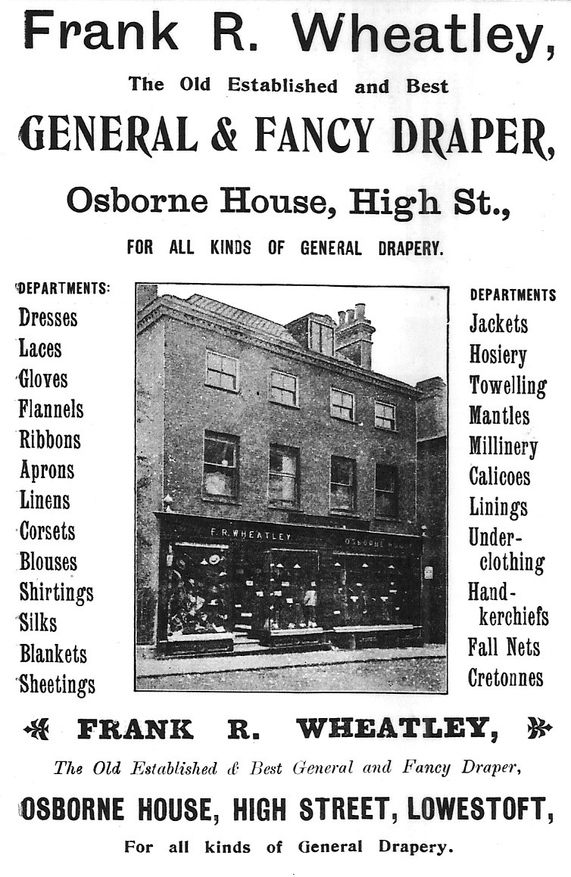
Newspaper Advert

Here's an old advert for Frank Wheatley's shop with an interesting list of all the different departments you could find on his premises.

If you had a shop, what would you sell?
Cakes?
Games?
Pens?
Sports equipment?

Make a list poem of all the things you would sell

Example:
My Sports Shop
Pink Nike boots, a football signed by Messi,
half-priced Man Utd shirt,
Harry Kane's socks, a tiny cricket bat,
a massive tennis racket, extreme trampolines,
invisible rugby balls and turbo powered roller-skates!
© Ivan Bunn Collection

Put your responses together, line-by-line, create a list poem about the Fancy Draper’s.

