The importance of local history and heritage projects in pupils’ learning

Local history and heritage studies are an integral part of the study of any historical issue, theme, event or person. Without them the study is partial; with them the study is complete.

Local history allows us to look at what was happening in a particular area and to see the extent to which it mirrors or differs from what was happening elsewhere.  As a result, it enables us to focus on a particular area and to move from the ‘local’ to the ‘national’ and often on to the ‘global’ scene.  It opens the doors from the particular and manageable study to the much larger and more complex study.  Thus, for children and young people local history can be the most appropriate access point for the study of history.  It enables them to become grounded in the past, to get their feet firmly placed in the period and become accustomed to the times they study before launching into a much broader and perhaps less concrete and less tangible study.  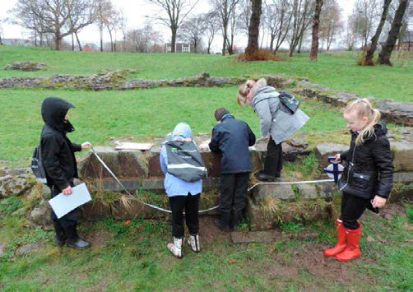 | Local history and heritage studies can bring enormous benefits for children and young people.  Some of the most important are that they enable them to:  - understand how and why their local community has developed in the way it has  - investigate the people and events that took place where they lived  - develop a sense of historical curiosity about their area and a sense of place  - see how their locality was involved in, responded to and was affected by regional, national and international events and actions – was their area typical or was it unique?  - understand why the area in which they live is worth knowing about  - be aware of the features of their local community and the extent to which they are an asset  - strengthen their chronological understanding and their appreciation of how and why some things change and others remain the same  - develop their enquiry skills and strengthen their skills in using a range of resources such as maps, photographs, census returns and directories  - increase their confidence and sense of achievement  - strengthen their knowledge and appreciation of their local community and forge stronger links with that community  - develop an identity and pride in where they live  - provide opportunities for out of class activities which are known to improve pupils physical and mental wellbeing

Ultimately, the study of local history and heritage:
- develops children’s and young people’s appreciation that these aspects of history are essential to explaining the national picture
- provides a more accessible introduction to national issues
- is often more absorbing and fascinating than the study of national and international history
- can provide easily accessible and manageable opportunities for whole-school and cross-curricular projects
- has strong links to history, geography and PSHE curriculum requirements and can link to other subject areas and develop literacy skills
- offers opportunities for teachers to develop new knowledge and skills as they enthuse their pupils and are themselves enthused by immersing themselves in the community

Pupils and families love learning about their locality so studying it is worth all the effort!

