This is a suggested script that teachers can use for each point on the trail, along with the accompanying PowerPoint images. Please ensure you read the introduction to the trail before embarking on it.
This trail on ‘African Lives in Newcastle’ has been designed in collaboration with African Lives in Northern England to stir curiosity and a sense of pride in Newcastle’s rich and diverse past. It will take you to places that African and Caribbean people lived and visited. These people all contributed to our region and their lives are embedded in the fabric of our region.
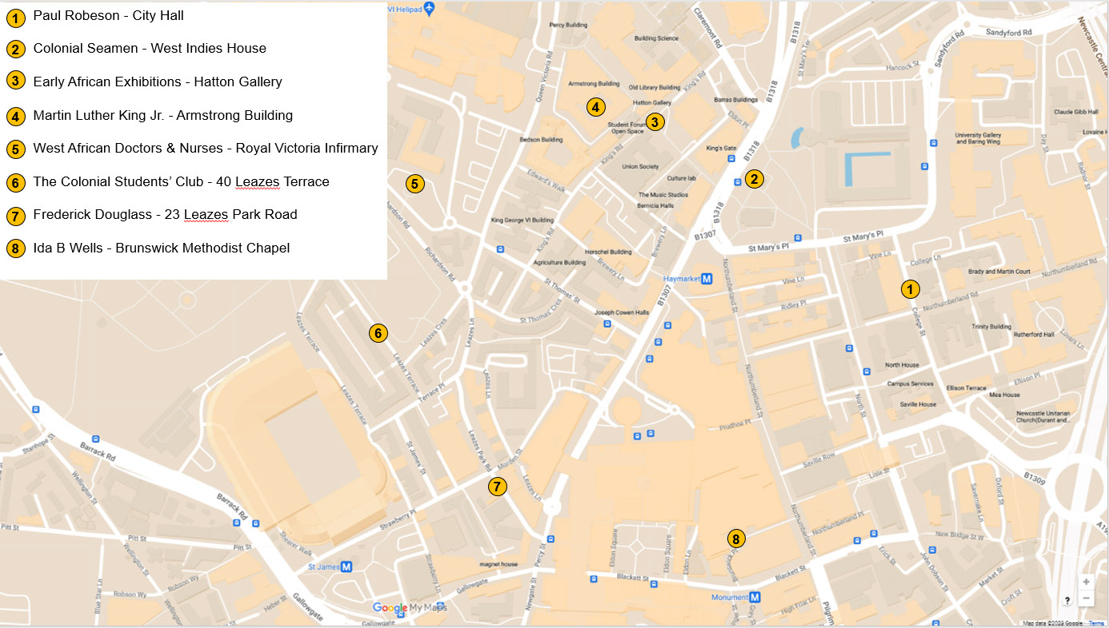

In the classroom, pupils can use the PPT and the StoryMap to revisit the people and buildings on the trail. For each person and place the StoryMap contains a wealth of additional information and images – to help stir pupils’ curiosity and gain an improved understanding of enslavement, discrimination and racism, whilst exploring the ways they can, and have, been challenged throughout history.

Content Warning – this trail, StoryMap and associated resources cover some topics that may be sensitive and could be upsetting. These include, but are not limited to:
- Point 3 - Early African Exhibitions and references to the ‘human zoo’
- Point 4 - Martin Luther King Jnr and references to his assassination.​
- Point 8 - Ida B Wells and references to ‘lynching’
Point 1: Paul Robeson (1898-1976) at City Hall
Location to stand whilst reading: https://w3w.co/storm.until.lived

Newcastle City Hall is a concert venue, which was built in 1927. It is now called the O2 City Hall. It was here that Paul Robeson sang, in 1958, to a packed audience. (Show PPT Slide image titled: Programme & ticket from Paul Robeson concert at City Hall)

Paul Robeson visited Newcastle and Gateshead several times in the 1930s, 1940s and 1950s. He delighted audiences with his songs, such as Old Man River and highlights of his successful acting career in England were his performances of Othello and in Showboat. (Show PPT Slide image titled: Paul Robeson concert as Othello)

From 1933, he supported the rights of black people and workers everywhere, despite the damage this caused to his career. He fought for equality and freedom for many different communities including the miners, the unions, the indigenous people of Australia and the African nations struggling for independence.

He was very outspoken and as a result his career and movements were blocked by the USA government. It was recently revealed that he was shadowed by security services on a visit to Tyneside and throughout much of his time in the UK,

He believed: "The artist must take sides. He must elect to fight for freedom or slavery. I have made my choice. I had no alternative."

Point 2: West Indies House and its Residents
Location to stand whilst reading: https://w3w.co/palace.gates.moral

West Indies House, at 14-16 Lovaine Place, was situated where Newcastle Civic Centre now stands. It was a Colonial Hostel established for African and Caribbean sailors in 1941/2. It was used accommodate black sailors left stranded in Tyneside at the outbreak of World War Two. (Show PPT Slide image titled: Houses on Lovaine Place prior to demolition, 1957)

The hostel was managed by Koi Obuadabang Larbi, a graduate in economics and a law student, from Ghana. It not only provided accommodation but also activities for sailors, such as Michael Yanni from Sierra Leone. Larbi was committed to creating a real ‘home away from home’ for the residents, with familiar foods and a range of facilities. (Show PPT Slide image titled: Koi Obuadabang Larbi, West Indies House, 1941)

Michael Yanni was born in 1918 in Sierra Leone. He sailed to England in 1941 to help with the war effort. In a BBC broadcast from West Indies House in 1942 he spoke highly of West Indies House and of Newcastle.

‘…there was a new hostel just opened in Newcastle for the coloured people… it is a fine building with sleeping accommodation for 60 and it supplies 200 meals a day.
There are good club rooms as well, with a library and a billiard room so we have plenty to do in our spare time. Mr Larbi of Accra also arranges for us interesting lectures on all kinds of subjects.’ (Show PPT Slide image titled: Mealtime at West Indies House, 1941)

Yanni stated in the BBC broadcast, managed by the Colonial Office, that he enjoyed Newcastle and that: ‘one could not be happier elsewhere than we are in Britain.’

This accommodation was used by others including the British Honduras forestry workers. In 1941 and 1942 around 840 foresters from British Honduras were recruited to increase the supply of timber needed by Britain during World War 2. They travelled from their Scottish timber camps to the cities for respite and many stayed at West Indies House.

West Indies House and the terraces in Lovaine Place were demolished in 1960 when building work started on Newcastle Civic Centre.
Point 3: Early African Exhibitions at The Hatton Gallery
Location to stand whilst reading: https://w3w.co/formed.doors.ties

In June 1943, an exhibition of African arts and crafts was held at the Hatton Gallery, Newcastle. The exhibition at The Hatton Gallery included exhibits of crafts such as leatherwork. The exhibition included events such as the visit of Fela Sowande, a musician and composer from Lagos, Nigeria, now considered the father of modern Nigerian Music. (Show PPT Slide image titled: “Africa to Tyneside” exhibition at The Hatton Gallery)

This was the second exhibition of African arts in the North East and was inspired by the Newcastle International Club and the Society for the Cultural Advancement of Africa in Newcastle. It was a response to an earlier exhibition which was held in 1929 on the Town Moor. (Show PPT Slide image titled: North Coast Exhibition, Town Moor, 1929)

At the Town Moor, Africans were exhibited in the “African Village”, in the amusement section of the North East Coast Exhibition. There were many objections to the exhibition from Africans locally and nationally, who called it ‘the human zoo’.

The official programme used the following description:

‘There is for example, the fine collection of wild animals from distant lands…. Then there is the African village where about 100 natives of West Africa live in a replica of one of their homeland communities… There is native dancing and there is music, not perhaps up to Chamber Concert standard but music, nevertheless. Accompanying the Senegalese is a tribe known as the Fullahs. These people are practically savages.’ (Show PPT Slide image titled: Engraving of a Fullah Lady)

This exhibition at The Town Moor is shocking to us and it is easy to see why Newcastle International Club and the Society for the Cultural Advancement of Africa sought to counteract this event with the exhibition at The Hatton Gallery.
Point 4: Martin Luther King Jnr. at Kings Hall, Newcastle University
Location to stand whilst reading: https://w3w.co/hired.transfers.rising
Martin Luther King, Jr. (1929-1968) was an American civil rights activist who led non-violent protests to fight for the rights of all people, particularly African Americans.

On 13 November 1967 Martin Luther King Jr. visited Newcastle University to receive an Honorary Degree. During the ceremony he gave a passionate speech about the challenges of poverty, racism and war. Having recently been released from Birmingham (USA) jail, King flew across the Atlantic, spending only three days in England and ten hours in Newcastle in order to receive the degree. (Show PPT Slide image titled: Martin Luther King Jr. at Newcastle University, 1967)

The Chief Clerk of the University, George Howe wrote to the local factory, asking them to pause work on the day to minimise noise! He also dealt with security for the event, making sure there was a university administrator to be on duty in the gallery of the King’s Hall to: ‘keep an eye open for the undesirable characters with toilet rolls and/or soft fruit'!

On 4th April 1968, 5 months after receiving the honorary degree from Newcastle University, Martin Luther King was shot dead in Memphis, USA. Newcastle University organised a Memorial Service in which the Vice-Chancellor gave a moving eulogy at King’s Memorial Service in St. Thomas’s Church, Haymarket. As part of King's eulogy Vice Chancellor Bosanquet’s said:

‘He told us we should bestir ourselves to ensure early and full acceptance of coloured people in Britain as completely equal citizens. If we delayed, then we should see the creation of areas of coloured poverty and the lightning flashes of mistrust and intolerance that might be the first signs of coming storms of violence.’

Martin Luther King Jr's legacy includes the ‘Letter from a Birmingham Jail’, his ‘I have a dream’ speech and the ‘unprepared and unforgettable speech’ he gave when accepting this degree. On the 50th anniversary of his assassination Newcastle University held a commemoration event, during which an image of him was projected onto the Students' Union building. (Show PPT Slide image titled: 50th anniversary light display at Newcastle University)
Point 5: Royal Victoria Infirmary and African Doctors
Location to stand whilst reading: https://w3w.co/passes.rising.safe

The Royal Victoria Infirmary was opened by Edward VII in 1906. Many West Africans worked at the Royal Victoria Infirmary during and after their training at Newcastle Medical College (NMC). The NMC is part of Durham University which had a partner college in Sierra Leone. Some of these West Africans include the following people

Irene Cole (Ighodaro) (1916-1995) She was born in Freetown, Sierra Leone. She entered Newcastle Medical School in 1938 and, in 1944, she became the first Sierra Leone woman to qualify as a doctor. She worked at the Royal Victoria Infirmary, specialising in gynaecology, and during the war worked in the hospital’s decontamination squad and treated war casualties. She advocated for women’s rights, health care and education in Nigeria and was awarded an MBE. (Show PPT Slide image titled: Irene Cole (Ighodaro) in graduation robes)

Irene Moduepolo Thomas (1917-2005) entered Newcastle Medical School in 1947, specialising in gynaecology. On returning to Nigeria, she became one of the first female doctors in the country. She co-founded the Motherless Babies Home, campaigned against female circumcision at local, national, and international levels and was awarded the Order of the Niger (OON). (Show PPT Slide image titled: Irene Moduepolo Thomas)

Ishmael Cummings (1882-1977) was born in Freetown, Sierra Leone. He studied medicine at Newcastle Medical College, Durham University, qualifying as a doctor in 1914. He became a Senior Doctor at the Royal Victoria Infirmary, Newcastle, and had his own practice at Burnopfield, County Durham. In 1916 he joined the colonial service as an African Medical Officer in Eastern Nigeria and later set up a successful general practice in Freetown in 1931.

Robert Wellesley-Cole (1907-1995), of Freetown, Sierra Leone, graduated from Fourah Bay College in 1927 and from Newcastle Medical College (Durham University) in 1934. He overcame racism to become the first African Fellow of the Royal College of Surgeons in 1944. He was instrumental in enabling potential nurses and doctors from Sierra Leone to access training in Newcastle. Wellesley-Cole was called ‘the black doctor’ with popular practices in Denton Burn and Whickham View, West Newcastle. (Show PPT Slide image titled: Robert Wellesley-Cole in graduation robes)

Teachers can talk about all 4 doctors or select 2 or 3 depending on time.
Point 6: The Colonial Students’ Club and its Residents
Location to stand whilst reading: https://w3w.co/jaws.learns.tools
The Colonial Students’ Club was founded in 1944 at 40 Leazes Terrace, to provide a centre of activity for black colonial students. It also had lodgings for a small number of these students. The club had nine beds and several meeting rooms.
The meeting rooms were used to formulate proposals to present to the Colonial Office for the development of West Africa, as well as for social activities and the African Friendship Society.

Some of the key people associated with the club were:

Ivor Cummings, the Colonial Welfare Officer, had responsibility for overseeing the welfare of students. The students were mostly from Sierra Leone, like Lois Bola Jones, Nigeria like Victor Oyenuga, as well as from the Gold Coast (Ghana) and Gambia.

Lois Bola Jones, born in 1919 in Sierra Leone, arrived in Newcastle in 1945 and lived at the Colonial Students’ Club. She had qualified as a nurse in Sierra Leone and was doing her midwifery training at Wingrove Hospital, Newcastle. Her residence in the Colonial Students’ Club, suggests that the club did not cater only for university students or just men, although most of the residents would have been male university students. (Show PPT Slide image titled: Lois Bola Jones in nurses’ uniform)

Victor Oyenuga (1917-2010) from Nigeria lived at the Colonial Students’ Club from 1945-1949, while he was doing his BSc in Agricultural Chemistry and his doctorate in Agricultural Biochemistry and Nutrition. He was the first Nigerian to receive these degrees from a British University. While undertaking his studies in Newcastle, he co-founded the African Friendship Society in the Colonial Students’ Club in 1947. (Show PPT Slide image titled: Victor Oyenuga in graduation robes)

Because of the racist and ignorant treatment, he had experienced both in the university and the city, he argued that: ‘the need for portraying cultural Africa to England for the benefit of both is overdue. The duty should be taken up by the Africans in this country.’

This club differed from the other African-led clubs in reaching out to wider society, giving talks to schools, youth groups and to the Sunderland International Friendship League.

Point 7: Frederick Douglass at Albion Street (now Leazes Park Road)
Location to stand whilst reading: https://w3w.co/supply.monks.taped
Frederick Douglass (1818-1895) was an American abolitionist, speaker, writer, and statesman. He travelled widely in Britain, speaking in Newcastle in 1846 and 1860. His speeches and his autobiographies greatly increased support for the abolition of enslavement. He became a celebrity in his own lifetime and also actively supported women’s suffrage. Frederick was enslaved himself and had escaped in 1838. (Show PPT Slide image titled: Frederick Douglass)

Frederick Douglass first travelled to the North East in 1846, lecturing against enslavement and promoting his first book, Narrative of the Life of Frederick Douglass, an American Slave, 1845. He spoke at the Salem Chapel, Hood Street, on August 3rd and 13th at meetings of the Newcastle Antislavery Society. On the first occasion, the 1200-capacity church was packed nearly to overflowing. (Show PPT Slide image titled: Salem Chapel, Hood Street, Newcastle)

On the same visit he spoke to a small gathering at 9 Albion Street, on 28th December 1846. Number 9 Albion Street, now 23 Leazes Park Road, was the home of Ellen Richardson and her family. Ellen and Anna Richardson, who were both Newcastle Quakers, had recently helped to raise £150 to buy his freedom from his American ‘owner’, from whom he’d escaped.

Douglass was so popular in the North East that according to The Newcastle Chronicle a special train was hired for the crowds from Sunderland, North and South Shields to attend his evening lecture in Gateshead. He reinvigorated the numerous anti-slavery societies in the North East and his freedom was bought by Henry and Anna Richardson, Newcastle Quakers.

He spoke at Nelson Street Music Hall in February 1860 during his second visit to Newcastle. He spoke of his joy that ‘Newcastle had a heart that could feel for three million of oppressed slaves in the United States of America’.

Frederick Douglass is the only person of African descent who has been recognised to date by Newcastle City with a plaque, installed at the Richardson’s home in Summerhill Grove in 2018.

The Frederick Douglass Centre, a stunning Newcastle University auditorium and lecture theatre was opened in 2018 by Kenneth B Morris Jr, the great, great, great grandson of Frederick Douglass.
Point 8: Ida B Wells at Brunswick Methodist Chapel
Location to stand whilst reading: https://what3words.com/grand.reader.radio

Ida B. Wells (1862-1931) was a journalist and a campaigner in the United States for the rights of African Americans, all women and all workers. She visited Newcastle in 1893 and 1894 to win financial and moral support for her anti-lynching campaign. (Lynching is when of a group of people kill someone for an alleged offence, without a legal trial, especially by hanging.) (Show PPT Slide image titled: Ida B Wells)

She co-founded the Alpha Suffrage Club in Chicago, USA, to further voting rights for all women, most particularly for black women. She openly challenged the marginalisation of black women in the 1913 National Women’s Suffrage Parade in Washington DC, USA.

Her campaign began when the black owners of the successful Peoples’ Grocery in Memphis, Tennessee, USA were lynched (murdered by a white mob) in 1892.

When she spoke at the Brunswick Methodist Chapel in Newcastle and elsewhere, she shocked the audiences with graphic stories of the mutilations and deaths of black men from lynching. She used the evidence from the investigations she had written about in her book Southern Horrors (1892). (Show PPT Slide image titled: Southern Horrors book cover)

Ida B. Wells was often attacked and isolated for her radical approach. However, she had the support of the abolitionist Frederick Douglass who publicly praised her courage. (Find out more about Frederick at Point 6)

She was posthumously awarded the Pulitzer Prize in 2020 for: ‘her outstanding and courageous reporting on the horrific and vicious violence against [4,084] African Americans during the era of lynching’.

Despite campaigning by many, the law making lynching a federal hate crime was only passed in 2022.

